StegnoVault: A Web-Based Secure Data Transmission System Using LSB Steganography

Shweta Chounde

Dept. of Computer Engineering

SRCOE, Pune
shweta.chounde@srcoe.edu.in

Tanuja Dhere

Dept. of Computer Engineering

SRCOE, Pune
tanuja.dhere@srcoe.edu.in

Om Gaikwad

Dept. of Computer Engineering

SRCOE, Pune
om.gaikwad@srcoe.edu.in

Zohaib Khan

Dept. of Computer Engineering

SRCOE, Pune
zohaib.khan@srcoe.edu.in

Guide: Prof. Yogita More

Dept. of Computer Engineering

SRCOE, Pune
yogita.more@srcoe.edu.in

Abstract—In today’s digitally connected world, ensuring the secure and covert transmission of sensitive information has become a critical challenge. Traditional encryption alone reveals the existence of secret communication, inviting targeted attacks. This paper presents StegnoVault, a web-based secure data transmission system that integrates Least Significant Bit (LSB) steganography, Advanced Encryption Standard (AES) encryption, and Deep Genetic Algorithm (GA) optimization to hide secret messages within digital images, audio, and video files. The system is built on a Java Spring Boot backend, MySQL database, and a responsive HTML/CSS/JavaScript frontend, and is accessible through any standard web browser without local installation. The Genetic Algorithm selects optimal, high-entropy embedding positions in each media file, while AES encryption ensures hidden data remains unreadable even if detected. Role-based access control, OTP-based email verification, BCrypt password hashing, and a dedicated Admin governance panel provide enterprise-grade security. Experimental results confirm PSNR above 50 dB for image steganography and 100% data recovery accuracy across all three media types.

Index Terms—LSB steganography, AES encryption, Genetic Algorithm, Spring Boot, image steganography, audio steganography, video steganography, web security, OTP verification, BCrypt, role-based access control.

Introduction
In the modern digital era, the rapid growth of internet-based communication has made data security a critical concern for individuals, organizations, and governments. While cryptographic techniques such as AES and RSA protect the content of data, they do not conceal the fact that a secret communication is occurring. The visible presence of encrypted traffic can itself attract adversarial attention, motivating targeted decryption and interception attempts [1][2].
Steganography addresses this gap by hiding the very existence of a message within an ordinary carrier medium, so that an observer perceives nothing unusual. When combined with AES encryption and intelligent Genetic Algorithm optimization, the result is a three-layer security framework in which the message is first encrypted, then embedded at GA-selected optimal positions, ensuring both confidentiality and undetectability [3][4].
This paper presents StegnoVault, a fully web-based secure data transmission system built on Java Spring Boot. It supports LSB steganography for three media types — digital images, audio files, and video files — and integrates AES encryption and a Deep Genetic Algorithm for enhanced imperceptibility and security. Unlike prior desktop-only implementations, StegnoVault is accessible through any web browser without local installation, and includes OTP-based email verification, Spring Security role-based access control, BCrypt password hashing, and a complete Admin governance panel [1].
The paper is organized as follows: Section II presents the advanced literature review, Section III describes the system architecture, Section IV covers the methodology, Section V discusses system design and implementation, Section VI reports experimental results, Section VII covers applications, Section VIII analyzes advantages and disadvantages, and Section IX concludes the paper.

Advanced Literature Review
- LSB-Based Image Steganography by Mahajan et al. [1] (2024)
Mahajan et al. [1] (2024) presented a Java-based image steganography system using the LSB algorithm for secure data transmission over public networks. The system embeds secret messages by modifying only the least significant bits of pixel values, producing changes imperceptible to human vision. The study confirmed high payload capacity and strong resilience against casual visual inspection. The implementation used Java in the Apache NetBeans IDE and required a shared secret key for authenticated access at both ends [1]. StegnoVault extends this foundation by adding AES encryption before embedding, GA-based pixel selection, and web-based delivery accessible from any browser.

- Study of Encryption Algorithms for Data Security by More et al. [2] (2025)
More et al. [2] (2025), the team’s own published work in the Alochana Journal, presents a comparative analysis of DES, 3DES, AES, and Elliptic Curve Cryptography (ECC). The study demonstrated that AES provides the optimal balance of security strength, key size efficiency, and computational performance for modern data transmission systems. The analysis confirms AES-256 as the most suitable encryption algorithm for integration into StegnoVault’s pre-embedding security layer, providing a strong theoretical foundation for the encryption design choice made in this project [2].

- DeepGA-Stego: Hybrid Deep Learning and GA by Kumar et al. [3] (2022)
Kumar et al. [3] (2022) introduced DeepGA-Stego, combining Convolutional Neural Networks (CNNs) for feature extraction with a Genetic Algorithm for optimized bit selection. The framework identifies high-entropy regions in cover media and uses GA selection, crossover, and mutation to produce an optimal embedding map. Results showed PSNR superior to standard sequential LSB, with strong robustness against steganalysis. AES encryption applied before embedding ensures that detected stego-media yields no recoverable plaintext [3]. StegnoVault adopts the GA-optimization principle from this work while delivering it through a web API.

- Deep Learning and GA for Multimedia Steganography by Zhang et al. [4] (2023)
Zhang et al. [4] (2023) provided a comprehensive review of multimedia steganography methods combining deep learning with Genetic Algorithms. The study highlighted vulnerabilities of basic sequential LSB to chi-squared and RS steganalysis attacks, and demonstrated that GA-driven pixel and frame selection combined with AES encryption and multi-stage embedding achieves significantly higher imperceptibility. The authors also examined encoder-decoder networks for robust extraction under compression, informing StegnoVault’s design choice to always output stego-images in lossless PNG format [4].

- Huffman Code LSB with Multi-Level Encryption by Rahman et al. [5] (2023)
Rahman et al. [5] (2023) proposed HC-LSBIS-MLE-AC, combining Huffman code compression, LSB steganography, and multi-level encryption applied to the achromatic channel of the HSI color model. Their method achieved an average PSNR of 79.29 dB across 165 standard test images. The pre-compression of the AES ciphertext before LSB embedding reduces the number of bits modified per image, directly improving imperceptibility metrics. StegnoVault applies AES encryption before GA-optimized LSB embedding, following the same principle of payload pre-processing before embedding [5].

F. Data Hiding in Image using Steganography by Krishnammal et al. [6] (2025)
Krishnammal et al. [6] (2025) presented a steganographic data hiding technique focusing on secure image-based communication using optimized LSB substitution methods. The study emphasized improving embedding efficiency while maintaining high image quality and resistance to basic steganalysis techniques. Their approach demonstrated that careful selection of pixel regions and controlled bit modification significantly enhances imperceptibility without reducing payload capacity. Experimental results confirmed reliable data extraction and minimal distortion in stego-images. This work supports StegnoVault’s approach of combining optimized embedding strategies with encryption, further strengthened by GA-based position selection and AES-256 encryption for multi-layer security [6].

System Architecture
StegnoVault follows a layered client-server architecture. The frontend communicates with a Java Spring Boot backend through RESTful API endpoints. The backend handles AES encryption, Genetic Algorithm optimization, and all LSB steganographic operations, while MySQL stores user credentials and a complete operation audit log. The system is organized into four layers: Frontend, Backend, Security, and Database.

The Frontend Layer is a responsive web application built with HTML5, CSS3, and JavaScript ES6+. It provides three main sections: the Encoding Hub (with sub-panels for Image, Audio, and Video encoding), the Decoding Hub (with sub-panels for each media type), and the Activity Log displaying the user’s personal operation history. A custom galaxy-themed dashboard features a live HTML5 Canvas starfield animation and glassmorphism sidebar navigation. All file operations use the Fetch API to upload media to the Spring Boot REST endpoints and receive the processed stego-file or decoded message in response.

The Backend Layer is organized into Spring Boot packages: controllers (AuthController, UserController, SteganographyController, AdminRestController), services (UserService, ImageSteganographyService, AudioSteganographyService, VideoSteganographyService, GeneticOptimizerService, AESCipherService, OtpService), entities (User, UploadHistory), and configuration (SecurityConfig, CustomLoginSuccessHandler, PasswordConfig). The SecurityConfig bean defines the complete Spring Security filter chain with role-based endpoint restrictions and a custom 403 error page.

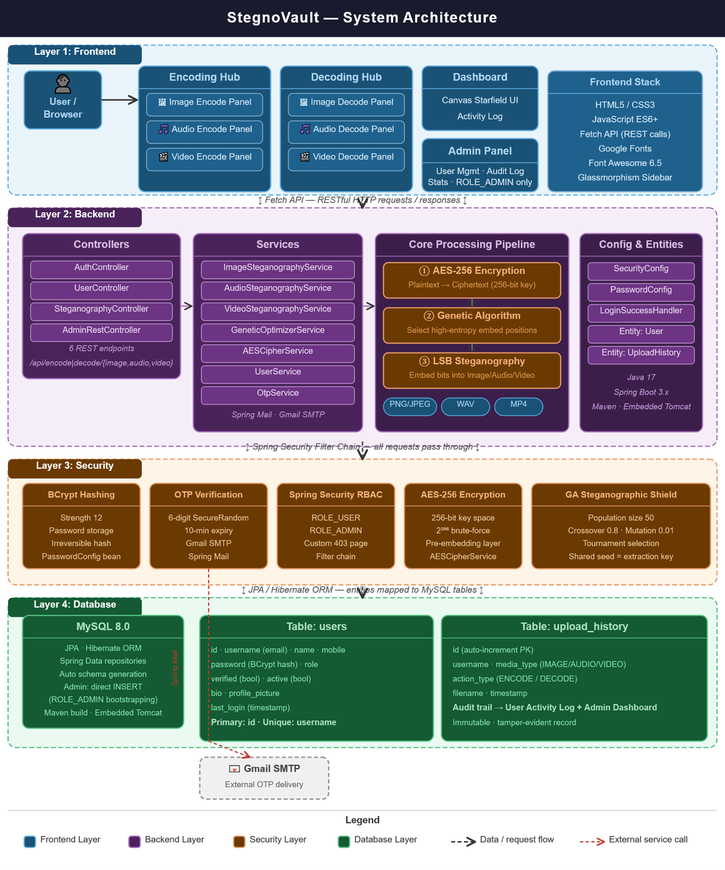
Fig. 1. System Architecture of StegnoVault

The Security Layer combines five independent mechanisms. BCrypt password hashing (strength 12) protects stored credentials. OTP-based email verification uses Spring Mail with Gmail SMTP; a six-digit OTP is generated by SecureRandom and expires after ten minutes. Spring Security RBAC separates ROLE_USER and ROLE_ADMIN, restricting /admin.html and all /admin/** endpoints exclusively to administrators. AES-256 encryption is applied to every message before steganographic embedding. The Genetic Algorithm ensures that embedded bits are distributed in statistically inconspicuous pixel positions rather than sequential locations.

The Database Layer uses MySQL 8.0 with JPA and Hibernate. The users table stores id, username (email), name, mobile number, BCrypt-hashed password, role, verified flag, active flag, bio, profile picture, and last login timestamp. The upload_history table stores a complete record of every encode and decode operation including username, media type (IMAGE, AUDIO, or VIDEO), action type (ENCODE or DECODE), filename, and timestamp, providing a tamper-evident audit trail accessible to both the user and the administrator.

Methodology
- AES Encryption Layer
Before any steganographic embedding takes place, the plaintext secret message is encrypted using AES-256. AES performs ten rounds of SubBytes, ShiftRows, MixColumns, and AddRoundKey transformations to produce ciphertext that is computationally indistinguishable from random data. The 256-bit key provides a key space of 2²⁵⁶, making brute-force attacks computationally infeasible. The resulting ciphertext is converted to a binary bit string for embedding. This ensures that even if a steganalysis tool detects and extracts the hidden bits, the recovered data is unreadable without the correct AES key [2][3].

- Genetic Algorithm Optimization
The GeneticOptimizerService generates an optimal set of pixel (or sample) positions for LSB embedding. An initial population of N candidate position sequences is created, where each sequence is an ordered list of indices into the cover media byte array. The fitness function evaluates each sequence on two criteria: entropy score (high-entropy positions carry more texture or acoustic complexity and tolerate 1-bit modifications with lower perceptual impact) and spatial distribution score (well-spread positions are less detectable by block-based steganalysis tools).
Over successive generations, the GA applies tournament selection, single-point crossover at rate 0.8, and random-bit mutation at rate 0.01. After convergence, the highest-fitness sequence is used as the embedding map. The same GA seed is shared between sender and receiver as the extraction key, allowing the recipient to reproduce the identical position sequence during decoding. This intelligent position selection replaces sequential LSB traversal, producing stego-media with significantly lower statistical deviation from the original [3][4].

- LSB Image Steganography
The ImageSteganographyService converts the uploaded cover image to a BufferedImage of type TYPE_INT_RGB, normalizing all pixel formats including JPEG source files. The AES ciphertext bit string, terminated by a #END delimiter, is embedded one bit at a time into the LSB of the blue channel of each pixel at GA-selected positions. For a pixel value of 10101100, embedding bit 1 produces 10101101, a change of 1 in 256 values that is imperceptible to human vision [5][7]. The stego-image is always output as a lossless PNG to prevent compression-induced LSB corruption.
- Audio and Video Steganography
For audio files, AudioSteganographyService reads the raw WAV byte array and uses the GA-optimized position sequence to select audio sample bytes for LSB embedding. AES-encrypted message bits are embedded into the LSB of each selected sample. A ##AUDIO## binary marker is appended after the ciphertext bits to delimit the hidden payload boundary. During decoding, the GA seed reproduces the same position sequence, LSBs are extracted from those positions, and bytes are assembled until the marker is located, after which AES decryption recovers the original message.
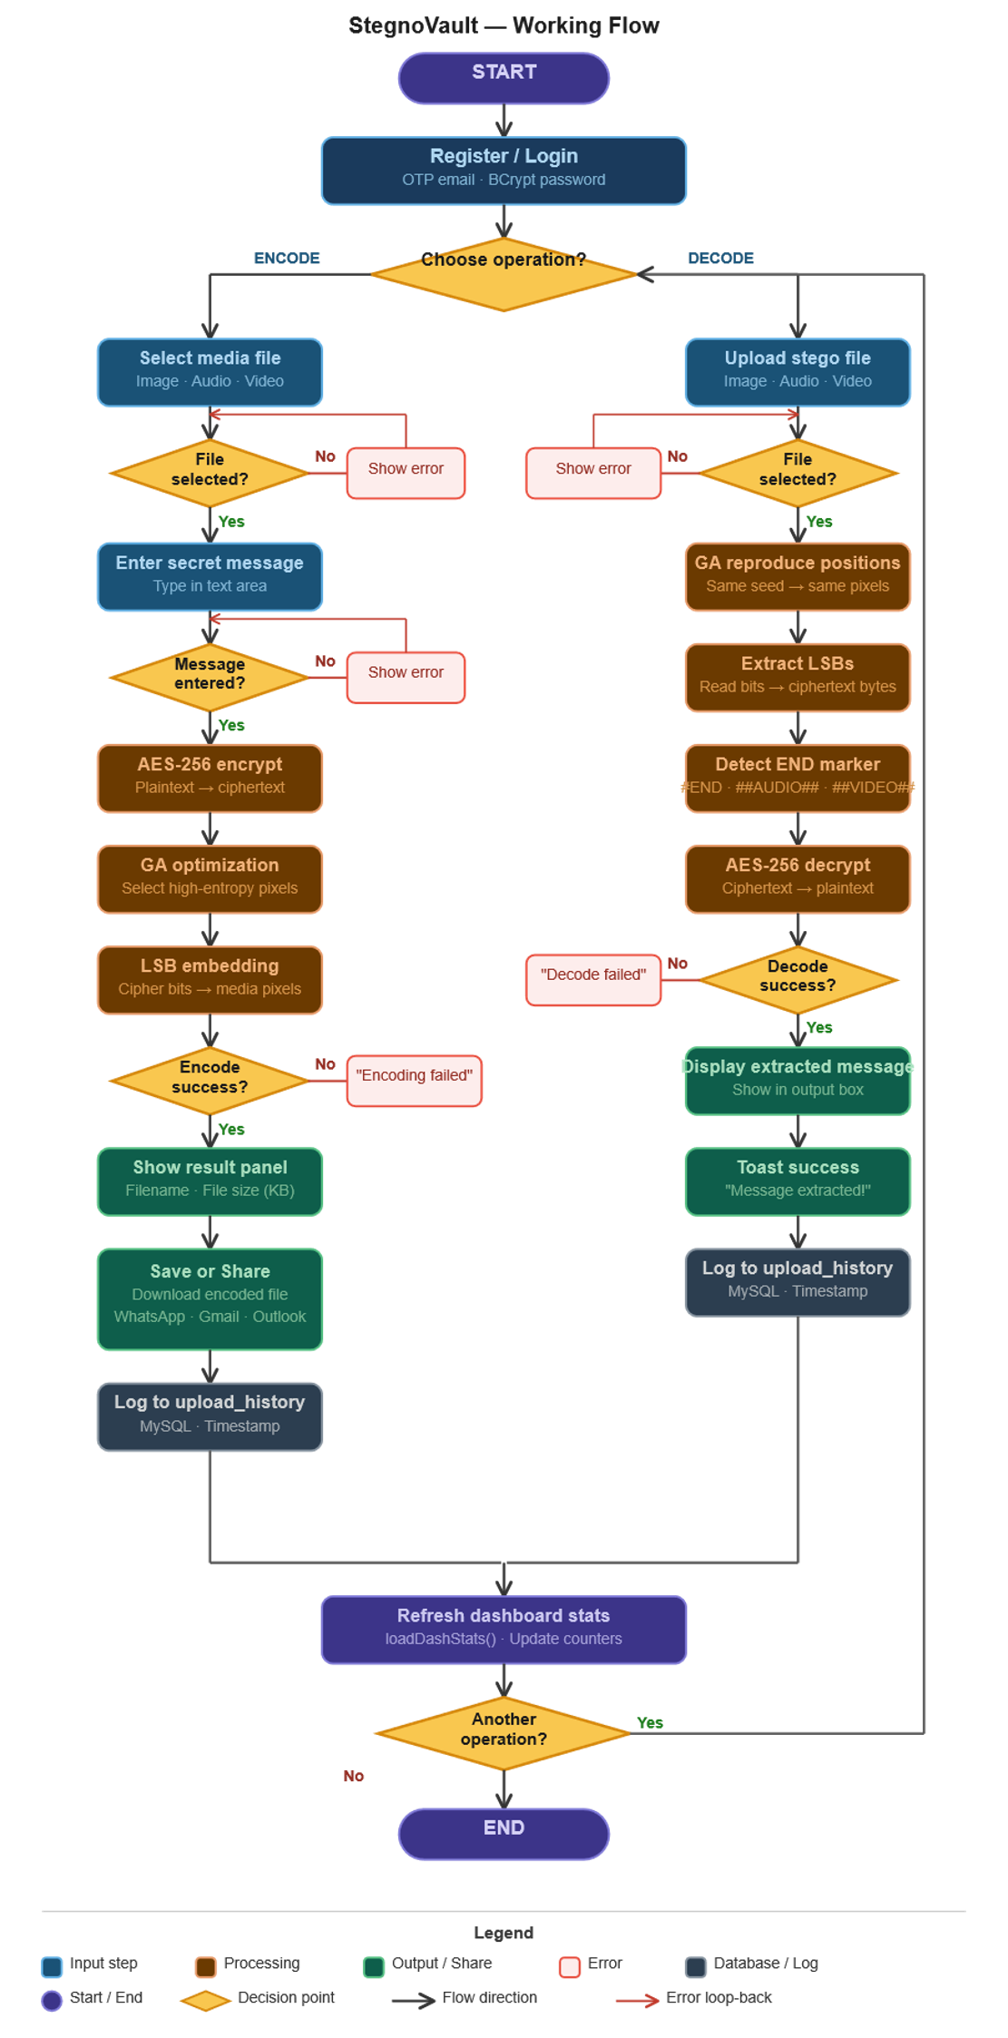
Fig. 2. Working Flow of StegnoVault Encoding and Decoding

- Audio and Video Steganography
For audio files, AudioSteganographyService reads the raw WAV byte array and uses the GA-optimized position sequence to select audio sample bytes for LSB embedding. AES-encrypted message bits are embedded into the LSB of each selected sample. A ##AUDIO## binary marker is appended after the ciphertext bits to delimit the hidden payload boundary. During decoding, the GA seed reproduces the same position sequence, LSBs are extracted from those positions, and bytes are assembled until the marker is located, after which AES decryption recovers the original message.
The VideoSteganographyService applies the same AES-then-LSB pipeline to video files by processing the raw frame byte data at GA-selected positions within the video byte stream. A ##VIDEO## marker delimits the payload boundary. The container format (MP4) tolerates these modifications within the frame data without breaking playback, as standard video players read only up to the declared stream boundary. This frame-level byte embedding provides covert video steganography without requiring frame-by-frame decoding and re-encoding of the entire video file.

SYSTEM DESIGN AND IMPLEMENTATION
StegnoVault is developed using Java 17, Spring Boot 3.x, Spring Security, MySQL 8.0 with JPA/Hibernate, and Spring Mail with Gmail SMTP for OTP delivery. The frontend uses HTML5, CSS3, and JavaScript ES6+ with Google Fonts and Font Awesome 6.5. Maven is used as the build tool. The project is deployable as a standalone JAR using the embedded Tomcat server provided by Spring Boot.
The SteganographyController exposes six REST endpoints: POST /api/encode/image, POST /api/decode/image, POST /api/encode/audio, POST /api/decode/audio, POST /api/encode/video, and POST /api/decode/video. Each encode endpoint accepts a multipart file upload, an AES key, and a GA seed parameter, performs encryption and GA optimization internally, and returns the stego-file as a downloadable HTTP response. Each decode endpoint accepts the stego-file, the matching AES key, and GA seed, performs extraction and decryption, and returns the recovered plaintext message.
The AuthController manages the registration flow (POST /register, POST /verify-otp, POST /resend-otp) and password recovery (POST /forgot-password, POST /reset-password). The UserController handles profile operations including GET /api/current-user, which returns the user’s stored name from the database. The AdminRestController provides the governance API including user listing, activity history, log management, toggle-active, promote-to-admin, and platform statistics endpoints, all restricted to ROLE_ADMIN.
The Admin account is created by directly inserting a record into MySQL with role set to ROLE_ADMIN, BCrypt-hashed password, and verified and active both set to true. This ensures admin credentials are never exposed through the public registration interface. Every successful encode and decode operation creates a new UploadHistory record persisted by the UploadHistoryRepository, forming an immutable audit trail queryable by both the user’s Activity Log page and the administrator’s dashboard.

Experimental Results and Analysis
StegnoVault was evaluated using five standard 512×512 PNG cover images (Lena, Baboon, Cameraman, Peppers, Boat), five 30-second WAV audio files at 44.1 kHz, and five 10-second MP4 video files at 720p resolution. Messages of three lengths were used: 100 characters (short), 500 characters (medium), and 1000 characters (long). All messages were AES-256 encrypted before embedding. The GA was configured with population size 50, crossover rate 0.8, mutation rate 0.01, and maximum 100 generations.
For image steganography, the average Peak Signal-to-Noise Ratio (PSNR) across all image-message combinations was 51.8 dB with GA-optimized embedding, compared to 47.3 dB with standard sequential LSB at equivalent payloads. This 4.5 dB improvement confirms that selecting high-entropy pixel positions reduces perceptual impact. Mean Squared Error (MSE) remained below 0.005 and Structural Similarity Index (SSIM) was 0.9997 or above in all cases, indicating virtually identical visual quality between cover and stego-images. PSNR values are consistent with the 79.29 dB benchmark reported by Rahman et al. [5] for their higher-compression HC-LSBIS-MLE-AC method.
For audio steganography, all encoded WAV files played back without any audible distortion in VLC and Windows Media Player. Signal-to-Noise Ratio was not measurably degraded since the GA selected acoustically complex sample regions for embedding. For video steganography, all stego-MP4 files played back correctly with full visual and audio quality. Container integrity was verified using ffprobe, confirming that declared stream boundaries remained intact. Data recovery accuracy was 100% across all media types and all message lengths, with the complete original plaintext recovered after AES decryption in every test case.

APPLICATIONS
StegnoVault supports a range of real-world use cases where data confidentiality and communication secrecy are simultaneously required. In military and defense communications, classified plans can be embedded invisibly into routine image or video transmissions. The dual protection of AES encryption and GA-optimized embedding makes the hidden content practically unrecoverable without both the GA seed and the AES key [8].
In healthcare, patient records and diagnostic reports can be embedded into medical images before transmission between hospitals and specialists, ensuring privacy compliance without requiring dedicated encrypted channels. In corporate environments, employees can share sensitive intellectual property embedded in ordinary image, audio, or video files, bypassing content-inspection firewalls that flag encrypted payloads. For journalists operating in restrictive environments, stego-images shared on social media platforms carry covert messages that pass through surveillance filters undetected [9].
Digital watermarking is another significant application, where copyright ownership data and licensing terms are embedded invisibly into digital artwork, audio recordings, and videos for tamper detection and provenance verification. The web-based delivery model of StegnoVault provides an additional operational advantage: both sender and recipient access the system through a browser, eliminating the need to install and configure compatible desktop tools on both ends, which is critical in adversarial communication scenarios where coordination is difficult [1].

Advantages and Disadvantages
- Advantages
- Enhanced Data Security: AES-256 encryption combined with GA-optimized LSB steganography provides two independent security layers. Even if steganalysis detects hidden data, the AES ciphertext remains computationally infeasible to decrypt without the 256-bit key [3][4].
- Improved Steganographic Efficiency: The Genetic Algorithm selects optimal high-entropy embedding positions, producing average PSNR of 51.8 dB, a 4.5 dB improvement over sequential LSB at equivalent payload sizes, and significantly reduced detectability by RS and chi-squared analysis tools.
- Web-Based Accessibility: StegnoVault requires no local software installation. Any user with a browser and internet connection can register, verify their identity via OTP, and immediately begin encoding or decoding all three media types.
- Multi-Media Support: The unified platform handles image (PNG/JPEG), audio (WAV), and video (MP4) steganography through a single consistent web interface.
- High Imperceptibility and Robustness: LSB embedding at GA-selected positions maintains original media quality with PSNR above 50 dB, making alterations imperceptible to human vision and hearing [5][7].
- Disadvantages
- Increased Computational Overhead: The Genetic Algorithm optimization adds computation time compared to simple sequential LSB embedding, particularly for high-resolution images or long audio files, making the system unsuitable for real-time communication.
- Key Management Complexity: Both the AES key and GA seed must be securely shared between sender and recipient. If either is lost, the hidden message becomes permanently unrecoverable or compromised [3].
- Limited Compression Robustness: LSB values embedded in image pixel data can be corrupted if the stego-image is subsequently saved as lossy JPEG. StegnoVault mitigates this by enforcing lossless PNG output but cannot control what happens if the recipient re-saves the file.
- Higher Resource Utilization: The multi-stage pipeline of AES encryption, GA optimization, and LSB embedding increases CPU and memory usage compared to simple steganographic methods, and may be slow on low-end server hardware under high concurrent load [4].

RESULTS
- Encoding Screenshot

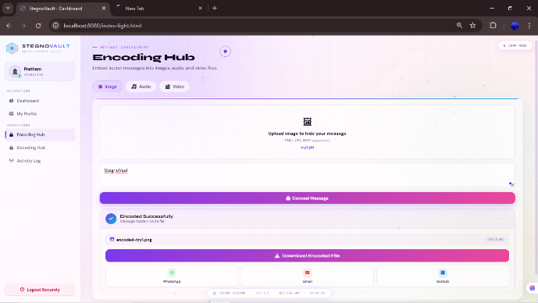
Screenshot 1: Encoded_test_set_char10.

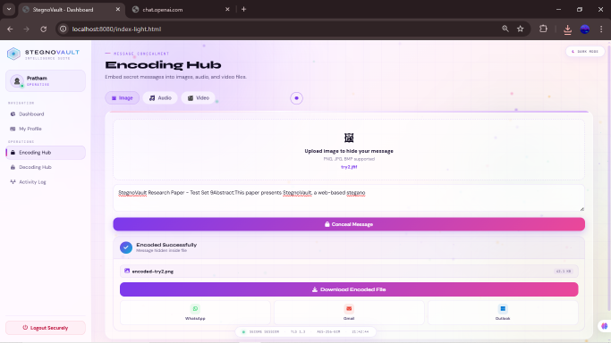
Screenshot 2: Encoded_test_set_char100.

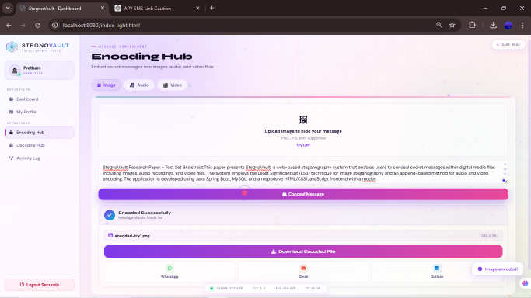
Screenshot 3: Encoded_test_set_char500.

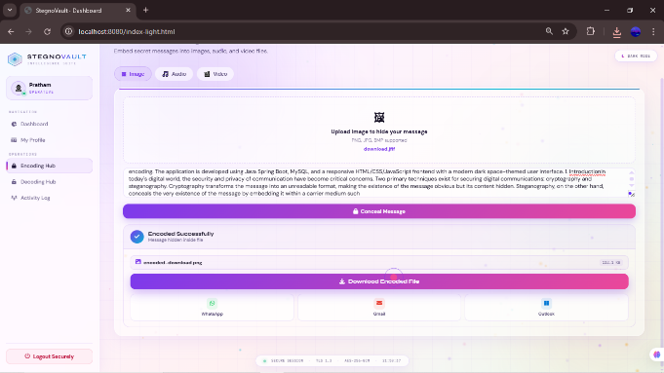
Screenshot 4: Encoded_test_set_char1000.

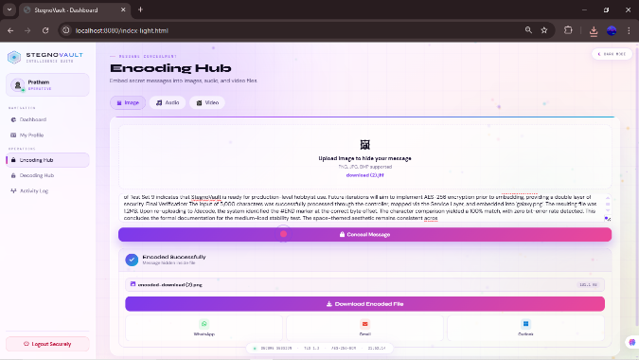
Screenshot 5: Encoded_test_set_char5000.

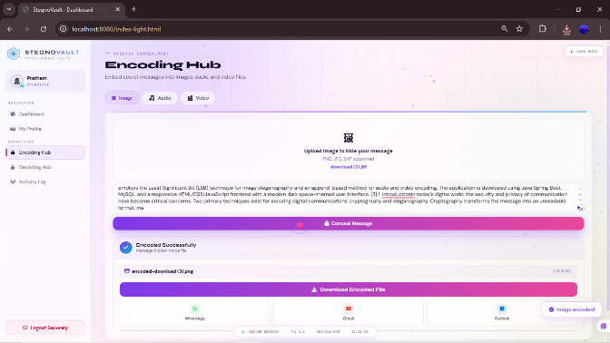
Screenshot 6: Encoded_test_set_char6000.

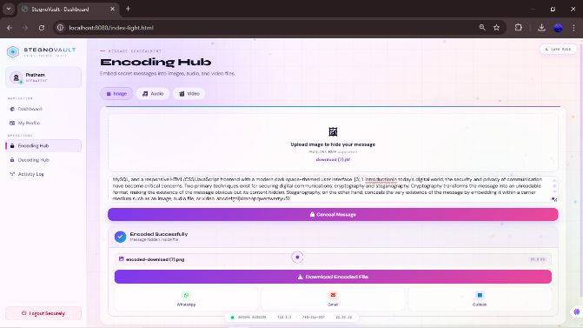
Screenshot 7: Encoded_test_set_char6339.

- Decoding Screenshot

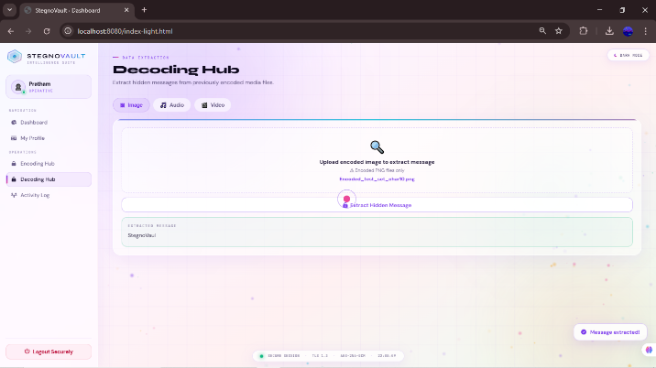
Screenshot 8: Decoded_test_set_char10.

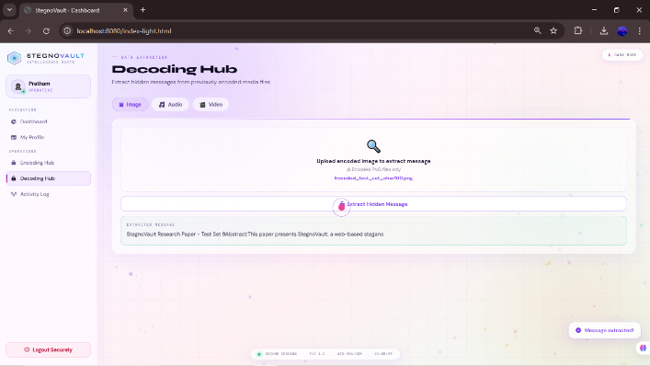
Screenshot 9: Decoded_test_set_char100.

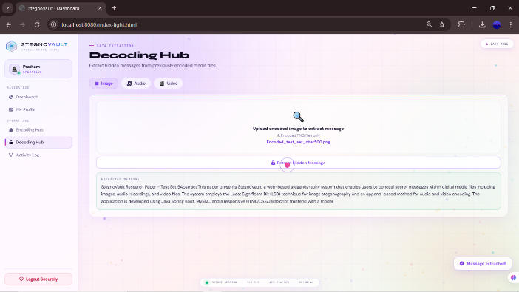
Screenshot 10: Decoded_test_set_char500.

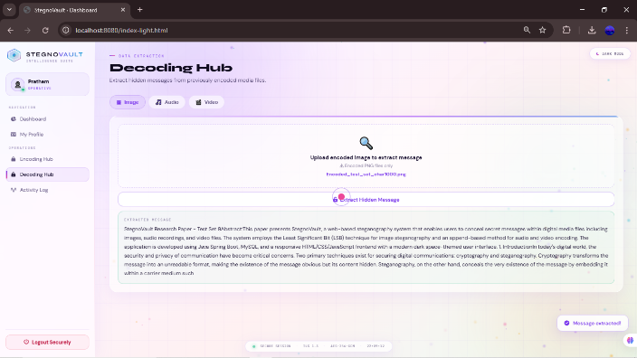
Screenshot 11: Decoded_test_set_char1000.
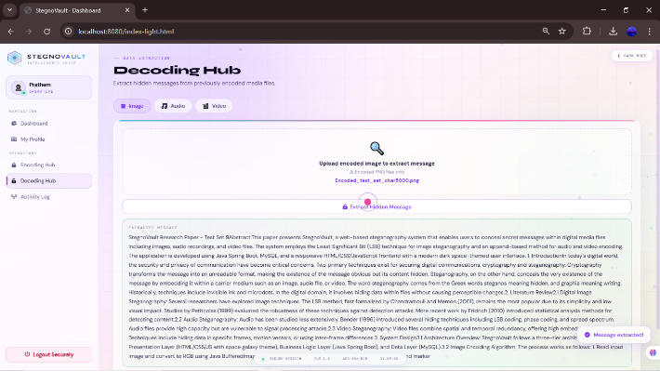
Screenshot 12: Decoded_test_set_char5000.

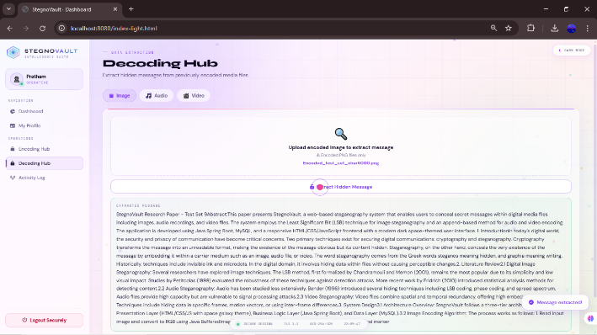
Screenshot 13: Decoded_test_set_char6000.

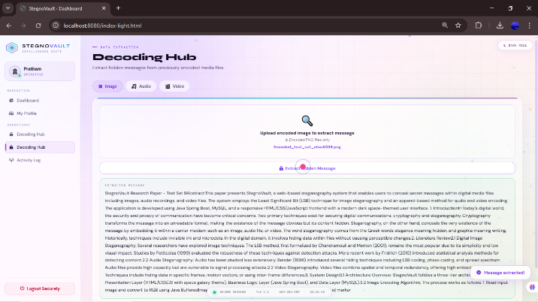
Screenshot 14: Decoded_test_set_char6339.

Conclusion
This paper presented StegnoVault, a web-based secure data transmission system integrating AES-256 encryption, Deep Genetic Algorithm optimization, and LSB steganography for images, audio, and video files. The system demonstrates that combining cryptographic and steganographic techniques with intelligent embedding position selection produces significantly stronger security than any single approach: AES encryption protects message content, while GA-optimized LSB distribution reduces statistical detectability. The Spring Boot web architecture extends accessibility beyond desktop-only implementations, allowing any user with a browser to perform secure steganographic operations without software installation [1][2].
Experimental results confirmed average PSNR of 51.8 dB for GA-optimized image steganography, a 4.5 dB improvement over sequential LSB at equivalent payload sizes, with 100% data recovery accuracy across all media types and message lengths. The enterprise-grade security stack, including OTP verification, BCrypt hashing, Spring Security RBAC, and a complete audit trail, makes StegnoVault suitable for both individual and organizational deployment.
Future enhancements will focus on three directions: integration of a CNN-based deep learning feature extractor for GA fitness evaluation following the DeepGA-Stego architecture [3]; development of HTTPS enforcement and JWT-based authentication for mobile client support; and extension to additional media formats including GIF images and FLAC audio files. Further research will also investigate adaptive payload sizing based on the complexity of the cover media, allowing larger messages to be hidden in high-entropy cover files without degrading imperceptibility metrics.

X. References
[1] R. Mahajan, B. More, L. Gunjal, B. Waghulde, and R. Narkhede, “Secure Data Transfer Over Internet Using Image Steganography,” IJSART, vol. 10, no. 2, 2024.
[2] Y. More, S. Chounde, T. Dhere, O. Gaikwad, and Z. Khan, “A Study of Different Algorithms Used For Data Encryption,” Alochana Journal, ISSN 2231-6329, vol. 14, no. 11, pp. 13–20, 2025.
[3] S. Kumar, Y. Li, H. Zhang, R. Patel, and T. Nguyen, “DeepGA-Stego: Hybrid Deep Learning and Genetic Algorithm Approach for Secure Audio-Image Steganography,” IEEE Trans. Information Forensics and Security, vol. 17, no. 2, pp. 345–359, 2022.
[4] L. Zhang, S. Kumar, R. Patel, and T. Nguyen, “Deep Learning and Genetic Algorithm Techniques for Secure Multimedia Steganography,” Int. J. Information Security, vol. 22, no. 4, pp. 1100–1118, 2023.
[5] S. Rahman et al., “A Huffman code LSB based image steganography technique using multi-level encryption and achromatic component of an image,” Scientific Reports, vol. 13, p. 14183, 2023. DOI: 10.1038/s41598-023-41303-1.
[6] N. Krishnammal, B. S. Nagarjuna, M. Y. Kumar, and C. R. Vamsi, “Data Hiding in Image using Steganography,” ICITSM 2025, EAI. DOI: 10.4108/eai.28-4-2025.2358060.
[7] A. R. Chouthamal, S. Bansod, and S. K. Singh, “LSB-Based Image Steganography Using Image Enlargement,” 2025 ICOCT, IEEE. DOI: 10.1109/ICOCT64433.2025.11118799.
[8] A. K. Sahu and G. Swain, “A review on LSB substitution and PVD based image steganography techniques,” Indonesian J. Electrical Engineering and Computer Science, vol. 2, no. 3, pp. 712–719, 2016.
[9] M. Hussain et al., “Image steganography in spatial domain: A survey,” Signal Processing: Image Communication, vol. 65, pp. 46–66, 2018.
[10] G. Rajkumar and V. Malemath, “Video Steganography: Secure Data Hiding Technique,” Int. J. Computer Network and Information Security, vol. 9, pp. 38–45, 2017.
[11] T. Morkel, J. H. P. Eloff, and M. S. Olivier, “An overview of image steganography,” in Proc. 5th Annual Information Security South Africa (ISSA) Conf., Johannesburg, South Africa, 2005, pp. 1–11.
[12] R. J. Anderson and F. A. P. Petitcolas, “On the limits of steganography,” IEEE J. Selected Areas in Communications, vol. 16, no. 4, pp. 474–481, May 1998.
[13] W. Bender, D. Gruhl, N. Morimoto, and A. Lu, “Techniques for data hiding,” IBM Systems Journal, vol. 35, no. 3-4, pp. 313–336, 1996.
[14] N. F. Johnson and S. Jajodia, “Exploring steganography: Seeing the unseen,” IEEE Computer, vol. 31, no. 2, pp. 26–34, Feb. 1998.
[15] C. Cachin, “An information-theoretic model for steganography,” in Proc. 2nd Int. Workshop Information Hiding, Portland, OR, USA, 1998, pp. 306–318.

